Figure S1 Alignment of partial amino acid sequences surrounding the Nudix motifs in VvNUDXs.

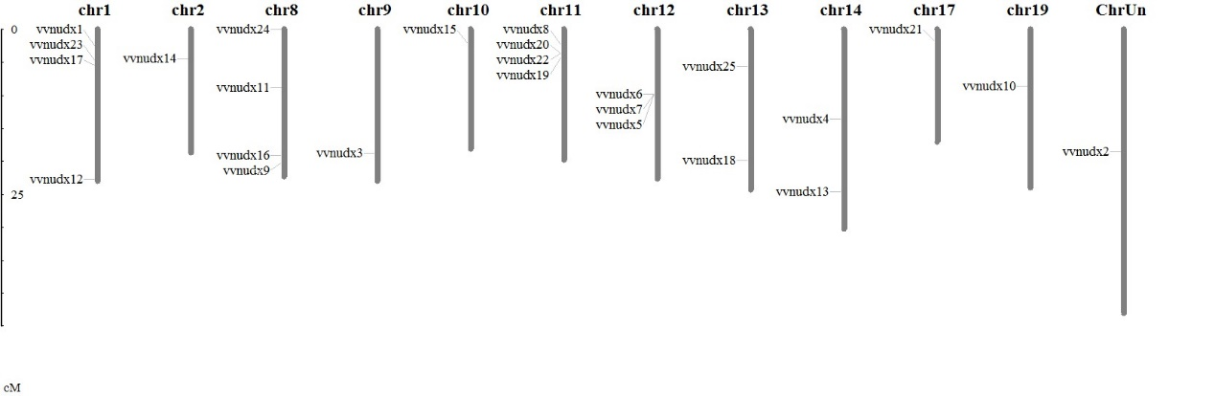
Figure S2 Chromosomal distribution of VvNUDX genes. Chromosome numbers are provided at the top of each chromosome together with the approximate size.

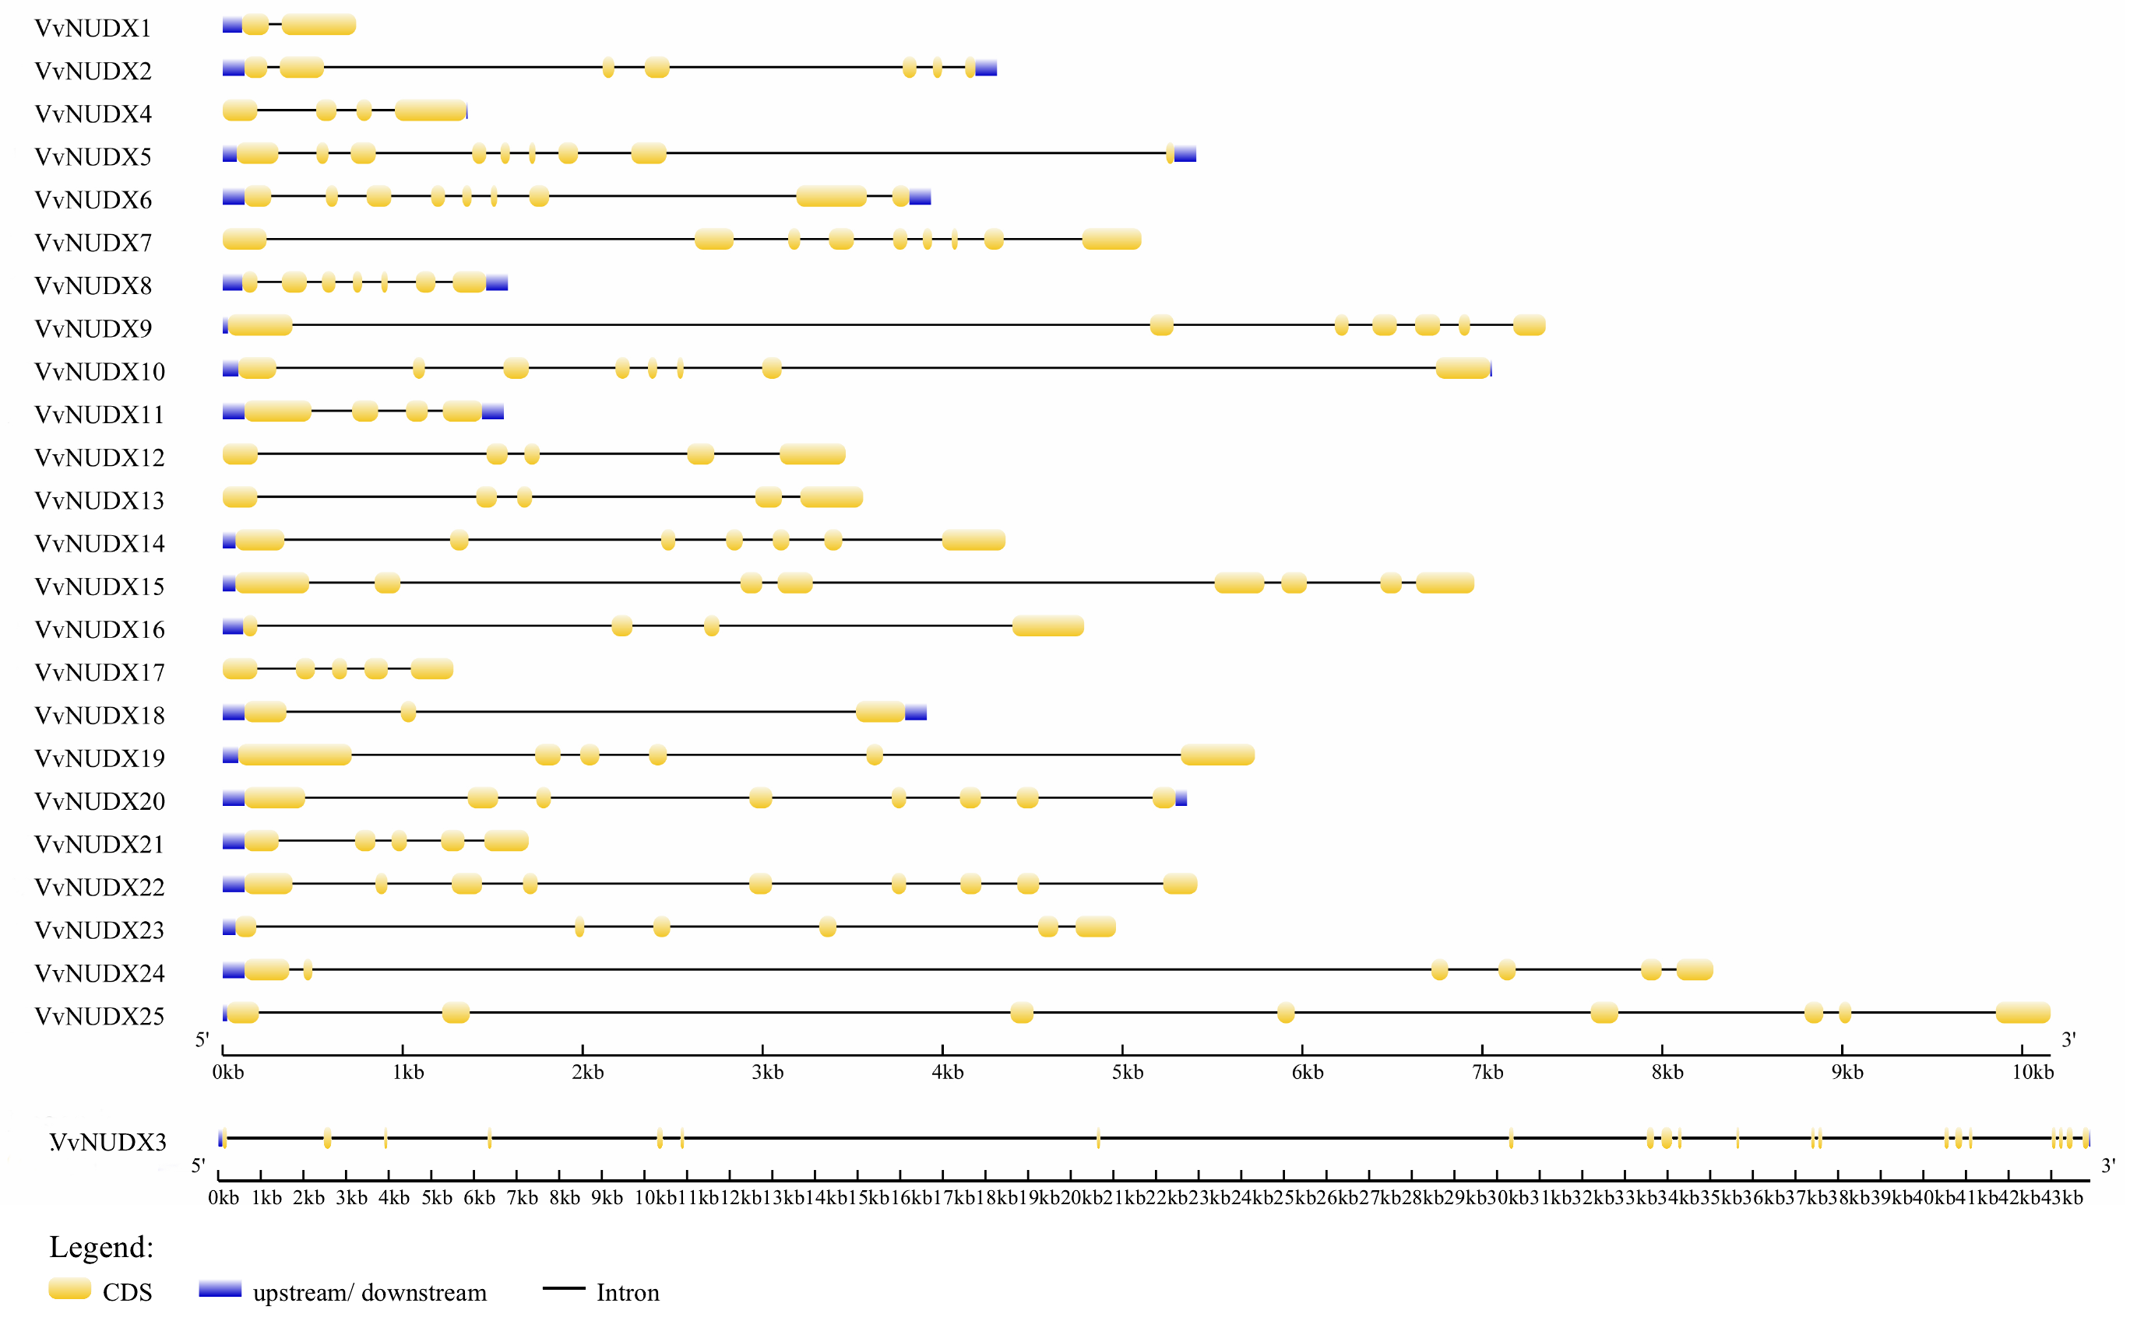
Figure S3 Gene structure of the VvNUDX family generated from GSDS. The yellow block means the coding sequence (CDS), the blue block means the upstream or downstream of the genes, and the black line indicates the intron. The scale bar indicates the length of the DNA sequences.

